**Purchasing Case Study**

**(Milestone 1)**

## 1. Background

This Case Study is based upon the purchasing activity of schools and colleges in a Local Education Authority. Please note that the scenario is an English one. In England, schools and colleges belong to a Local Authority. In other countries, the arrangements will be different, but exactly the same principles will apply to any organisation which has a number of outlets, each of which needs to purchase supplies (for example, a chain of estate agents or insurance offices or branches of a bank).

Pebbleshire County Council’s Education Department has 150 institutions ranging from primary schools to Colleges of Further Education. The department’s central administration is based at County Hall and, within this there is a Central Purchasing Section (CPS) which plays a part in this Case Study.

The CPS deals with large-scale purchases such as major refits and items for new buildings. It also acts as a centre for advice about purchasing matters. Other major items of expenditure such as salaries and staff training are dealt with by other sections in County Hall and do not concern us here.

All other purchases are dealt with by the institutions themselves under the control of the Head. Institutions are responsible for the purchase of equipment, consumables, books, items of furniture, transport…etc., and it is this aspect which is under investigation in this Case Study.

## 2. The Current System

### 2.1 The Budget

Each year, County Hall allocates a sum of money to each institution called its capitation. This amount is based on a formula related to the numbers and ages of pupils which the institution has on its roll. The capitation is the amount of money that the Head can spend in the following year.

How the Head chooses to spend the money is largely up to him/her but normal practice is for each Department, or cost centre, within the institution (e.g. maths, science, history etc.) to be invited to put in an itemised bid for part of the capitation. The total value of these bids normally exceeds the money available by a considerable margin. The Head and the management team usually have to trim them down based on priorities which reflect their current policy.

Eventually, a budget is established for each Department (or cost centre). The number of cost centres will vary considerably ranging from 5 or 6 for primary schools (where there are no real departments) to 20 or 30 in the larger institutions. The agreed budgets are entered into an account book with a number of pages allocated to each cost centre.

### 2.2 Purchasing Activity

When a Department wishes to make a purchase, a 3-part purchase order is made out. Pens, pencils, rulers etc. are ordered from the County Council stores for which each institution has a price list. Orders for other items are placed with outside suppliers. How the supplier is selected is described in Section 2.4. The 3-part purchase order is sent to the Head’s Office. The order is checked against the budget balance for that cost centre and signed by the Head if the budget has not been exceeded. The purchase order number and date are entered into the account book and the new budget balance calculated and entered. The top copy of the order is sent to the supplier, the second is filed and the third sent to the Central Purchasing Section at County Hall.

When the ordered goods arrive, the delivery note is checked against the purchase order and if there is any problem with the goods the supplier is contacted or the goods sent back with the delivery note. In exceptional circumstances, a purchase order may be cancelled and, in this case, the CPS is informed and the account book amended accordingly. The delivery note is filed with the purchase order. When the invoice arrives, it is checked against the purchase order and the delivery note and signed by the Head as being passed for payment. The invoice number, date and related purchase order number(s) are entered into an invoice book and the invoice is then forwarded to the Accounts Department at County Hall for payment.

Once a month, an expenditure report is received from the Accounts Department detailing invoices paid. This is reconciled with the entries in the invoice book and any discrepancies are taken up with County Hall. Purchase orders which have been paid are extracted and placed in a separate file and details entered into the budget account book.

### 2.3 The Purchase Order

A copy of the purchase order appears later in this Case Study in Section 3.3. The individual items on the order are allocated a product code. This is used by the CPS for searching and analysis and is of a general nature. For example, all stationery items are given the code 0185, all chairs, stools, benches etc. are given a code of 0140 (seating), 0170 is for filing cabinets, racking and shelving and so on. These product codes rarely change and each institution has a list of them.

### 2.4 The Choice of Suppliers

When an institution makes a purchase, they normally refer to supplier catalogues. The Education Department often has special deals with suppliers and institutions find out about these from the CPS. The CPS has close links with suppliers and maintains files containing supplier details, up-to-date catalogues and information on special offers and deals.

Institutions can, and often do, ask the CPS for advice about a particular product or supplier. The CPS will forward details of special offers and may also search through past purchase orders for details of other institutions which have purchased similar equipment. The relevant name and telephone number are then passed to the enquirer. However, searching through past purchase orders is difficult because of:

1. The large number of purchase orders and
2. The general nature of the product codes. For example, laboratory stools would come under the same product code (0140) as benches.

As a result, searching through past purchase orders is not often undertaken.

## 3. The System Investigation

### 3.1 Current Computer Facilities

The County Council’s long-term plans for information technology are ambitious. The majority of institutions are linked to a central computer facility at County Hall in preparation for an integrated management information system. It is planned to link all of them in the near future. There is plenty of spare capacity on the system at County Hall.

### 3.2 Scope of Investigation

A systems analyst from the County Council’s computer department has been given the task of investigating current purchasing activity in the institutions with a view to producing an automated system which will assist purchasers in buying goods of high quality and durability at reasonable prices. One of the constraints imposed upon the analyst is that any computer solution must use the existing computer facilities in the institutions and at County Hall.

The investigation is part of a long-term strategy for financial systems which will eventually require that purchase orders be stored on a computer for use in an integrated accounting system.

### 3.3 Example Purchase Order

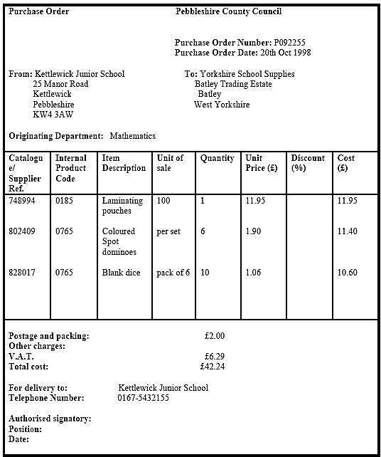

## 4. Case Study Requirements

This is a group project. You must divide yourselves into groups of four. Each group will contain a Project manager, Business Analyst and 2 Developers (Tester, UX/UI, ….)

A new Web-based application is required to be developed. Therefore, you are required to produce a professional report documenting the new system. Your report should contain the following:

* The State chart of the order request
* Activity Diagram
* BPMN Diagrams
* Running BPMN process using Camunda
* BPMN Forms

• Any assumptions made (if in doubt consult your module tutor)

## 5. Important Notes:

Handwritten diagrams will NOT BE ACCEPTED, and the group will be awarded ZERO for the project.

The tool is downloadable from the following link:

https://camunda.com/download/modeler/

* Each group must show their work in a power point presentation
* Each group must submit a word document and the BPMN files
* It is important that the work submitted is your own. Plagiarism and/or collusion will result in a possible disciplinary action.
* All group members should attend the final discussion.
* The absence of any group member will be taken with a penalty.
* Late submissions within will be taken with a penalty.

The due date for submitting this project is Saturday 19 November 2022

**Good Luck ☺**